Version 1 & Version 2 — ML + RAG + Agentic Reasoning System
Prepared by: Bhagya
Date: April 6, 2026
Company: Personal

1. Overview
The Fraud Detection MVP is a two‑stage system combining traditional machine‑learning–based fraud scoring with modern GenAI‑powered reasoning. It is designed to demonstrate how deterministic models and retrieval‑augmented agentic reasoning can work together to produce transparent, auditable fraud decisions.
The system includes:
- Version 1 — A RandomForestClassifier‑based fraud scoring API
- Version 2 — A hybrid ML + RAG + Agentic Reasoning API
Both versions are implemented using FastAPI, Python 3.12, and joblib‑based model artifacts.

2. Version 1 Summary
Version 1 provides a traditional machine‑learning fraud scoring pipeline:
Key Features
- Synthetic transaction dataset generation
- Feature engineering using one‑hot encoding
- RandomForestClassifier model training
- Fraud probability scoring endpoint
- SQLite‑based alert logging
- Deterministic, explainable output
API Endpoint

Output
- Fraud probability
- Binary fraud decision
- Simple rule‑based explanation
Version 1 establishes the baseline model and artifacts used in Version 2.

3. Version 2 Summary
Version 2 extends the system with a GenAI‑powered reasoning layer.
Key Enhancements
- Reuses Version 1 model and feature pipeline
- Adds RAG (policy + case retrieval)
- Adds agentic reasoning for contextual decisions
- Produces detailed, policy‑grounded explanations
- Supports richer transaction payloads
API Endpoint

Output
- from the RandomForest model
- containing:
- Final decision
- Explanation
- Policy justification
- Case justification
Version 2 demonstrates how ML + GenAI can produce transparent, auditable fraud decisions suitable for regulated environments.

4. Installation Instructions
1. Create a virtual environment

2. Activate the environment
Windows:
3. Install dependencies
5. Running Version 1
Start the API
Open Swagger UI
6. Running Version 2
Start the API
Open Swagger UI

7. API Inputs and Outputs
Version 1 Input
- customer_id
- amount
- country
- channel
- hour
Version 1 Output
- fraud_probability
- is_fraud
- explanation

Version 2 Input
- transaction_id
- customer_id
- amount
- merchant
- location
- country
- channel
- hour
- timestamp
Version 2 Output

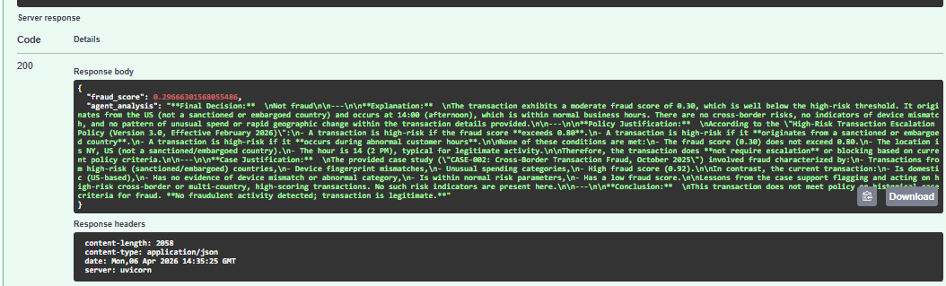

8. Artifacts
The following artifacts are required for both versions:
- — RandomForestClassifier
- — Ordered feature list
These artifacts are generated by Version 1 and consumed by Version 2.

- Model scoring
- Feature alignment
- RAG retrieval
- Agentic reasoning
- Error handling
- Schema validation

